Ben Johnson

CMPS 1600

Project 0

**Facebooklet User-Manual**

*FacebookletProfile Class:*

The FacebookletProfile represents the user profile. This class encapsulates all the information required for the social network, including the user name, user status, user friends, and the unique node ID. This class also contains the standard getter and setter methods, methods to add and remove friends, and a method to return a human-readable representation of the data stored in the profile.

*FacebookletNode Class:*

The FacebookletNode abstract class provides a framework for the various types of nodes in the Facebooklet network, including profiles. It contains the node ID variable, as well as a getter and setter method for that ID

*FacebookletDatabase Class:*

The FacebookletDatabase class is used to store the data created by this program, and keep track of the various nodes in the network. The data profiles created in an array list, as well as a method to return add or remove nodes from the database, return a friendly string of all nodes. The database also contains two methods to write the database’s data to a file, and read data from a file to store into a database.

*Facebooklet Class:*

The Facebooklet class ties the rest of the project, and is responsible for conducting user interaction. It contains the constructor responsible for implementing the GUI.

Below is a guide to operate the GUI.

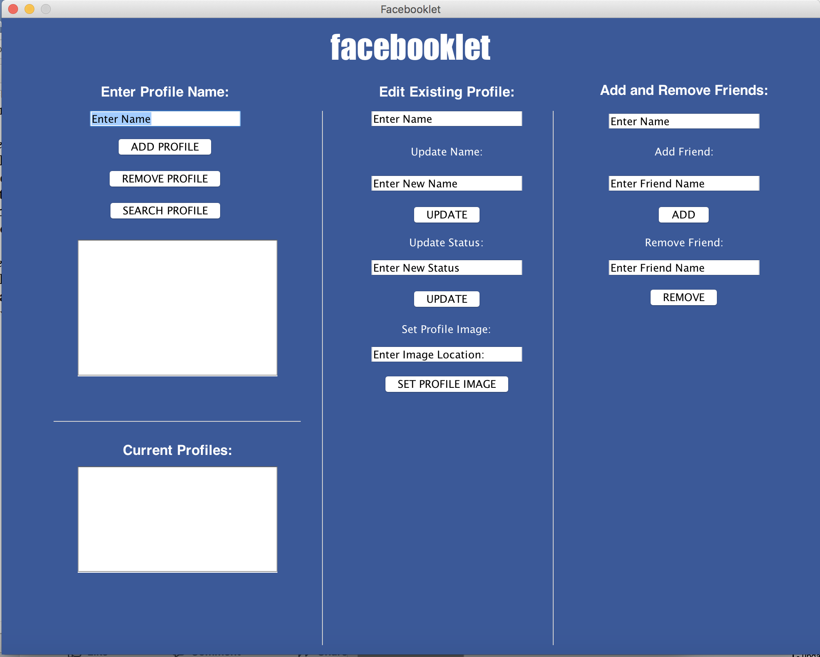

*Left Panel:*

The left panel is responsible for basic profile operations, and for displaying current profiles. When a profile name is entered into the Text Field, the user has the option to add the profile to the database, remove it from the database, and search for the profile in the database. When the SEARCH PROFILE button is pressed, the data of said profile will be displayed in the Text Area below.

Below those buttons is another Text Area, which displays all of the profiles currently in the database.

*Middle Panel:*

The middle panel is responsible for updating existing profiles. When an existing profile is entered into the first Text Feld underneath “Edit Existing Profile”, it’s data can be changed using the other Text Fields and Buttons

*Right Panel*

The right panel is responsible for creating links between different profiles. The user must enter an existing panel into the first Text Field, and then another existing profile into either the add friend or remove friend Text Field. When the ADD button is pressed, the two profiles become friends, and when the REMOVE button is pressed, the two profiles are no longer friends.